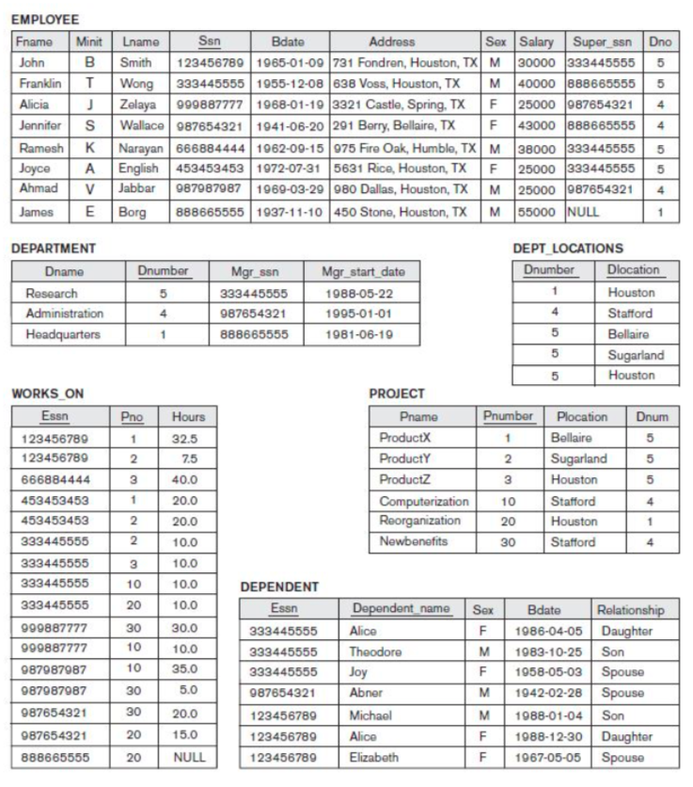

1. ***Specify the following queries based on the Nested Queries concepts on the database above in SQL. Show the query results.*** 
   1. ***For each department whose average employee salary is more than $30,000, retrieve the department name and the number of employees working for that department.***

[SELECT](http://localhost:8888/phpMyAdmin/url.php?url=https://dev.mysql.com/doc/refman/5.5/en/select.html) D.dname, [COUNT](http://localhost:8888/phpMyAdmin/url.php?url=https://dev.mysql.com/doc/refman/5.5/en/group-by-functions.html#function_count)(\*) as "Number of Employees"

FROM department as D, employee as E

WHERE D.dnumber = E.dno

GROUP BY D.dnumber

HAVING [AVG](http://localhost:8888/phpMyAdmin/url.php?url=https://dev.mysql.com/doc/refman/5.5/en/group-by-functions.html#function_avg)(E.salary) > 30000

* 1. ***Suppose we want the number of male employees in each department rather than all employees. Can we specify this query in SQL? Why or why not? Show the query results if applied to the database.***Yes, we can specify such query in database as we have employees’ gender stored in ‘sex’ attribute of ‘employee’ table.

[SELECT](http://localhost:8888/phpMyAdmin/url.php?url=https://dev.mysql.com/doc/refman/5.5/en/select.html) D.dname, [COUNT](http://localhost:8888/phpMyAdmin/url.php?url=https://dev.mysql.com/doc/refman/5.5/en/group-by-functions.html#function_count)(\*) as "Number of Male Employees"

FROM department as D, employee as E

WHERE D.dnumber = E.dno

[AND](http://localhost:8888/phpMyAdmin/url.php?url=https://dev.mysql.com/doc/refman/5.5/en/logical-operators.html#operator_and) E.sex [LIKE](http://localhost:8888/phpMyAdmin/url.php?url=https://dev.mysql.com/doc/refman/5.5/en/string-comparison-functions.html#operator_like) 'M'

GROUP BY D.dnumber  
  
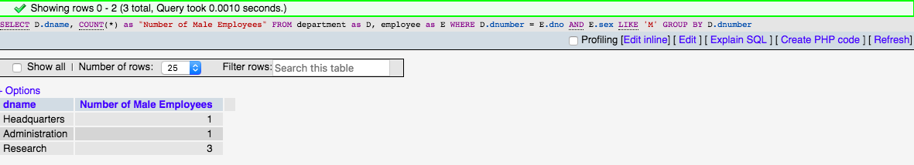

* 1. ***Retrieve the names of all employees who work in the department that has the employee with the highest salary among all employees.***

[SELECT](http://localhost:8888/phpMyAdmin/url.php?url=https://dev.mysql.com/doc/refman/5.5/en/select.html) CONCAT(fname, " ", minit, " ", lname) AS "Name"

FROM employee

WHERE dno [IN](http://localhost:8888/phpMyAdmin/url.php?url=https://dev.mysql.com/doc/refman/5.5/en/comparison-operators.html#function_in) (

[SELECT](http://localhost:8888/phpMyAdmin/url.php?url=https://dev.mysql.com/doc/refman/5.5/en/select.html) dno

FROM employee

WHERE salary = (

[SELECT](http://localhost:8888/phpMyAdmin/url.php?url=https://dev.mysql.com/doc/refman/5.5/en/select.html) [MAX](http://localhost:8888/phpMyAdmin/url.php?url=https://dev.mysql.com/doc/refman/5.5/en/group-by-functions.html#function_max)(salary)

FROM employee

)

)

* 1. ***Retrieve the names of all employees whose supervisor’s supervisor has ‘888665555’ for Ssn.***

[SELECT](http://localhost:8888/phpMyAdmin/url.php?url=https://dev.mysql.com/doc/refman/5.5/en/select.html) CONCAT(fname, " ", minit, " ", lname) AS "Name"

FROM employee

WHERE super\_ssn [IN](http://localhost:8888/phpMyAdmin/url.php?url=https://dev.mysql.com/doc/refman/5.5/en/comparison-operators.html#function_in) (

[SELECT](http://localhost:8888/phpMyAdmin/url.php?url=https://dev.mysql.com/doc/refman/5.5/en/select.html) ssn

FROM employee

WHERE super\_ssn = 888665555

)

* 1. ***Retrieve the names of employees who make at least $10,000 more than the employee who is paid the least in the company.***

[SELECT](http://localhost:8888/phpMyAdmin/url.php?url=https://dev.mysql.com/doc/refman/5.5/en/select.html) CONCAT(fname, " ", minit, " ", lname) AS "Name"

FROM employee

WHERE salary > 10000 + (

[SELECT](http://localhost:8888/phpMyAdmin/url.php?url=https://dev.mysql.com/doc/refman/5.5/en/select.html) [MIN](http://localhost:8888/phpMyAdmin/url.php?url=https://dev.mysql.com/doc/refman/5.5/en/group-by-functions.html#function_min)(salary) FROM employee

)

1. ***Specify the following views in SQL on the COMPANY database schema shown in the Figure above.***
   1. ***A view that has the department name, manager name, and manager salary for every department.***

[CREATE](http://localhost:8888/phpMyAdmin/url.php?url=https://dev.mysql.com/doc/refman/5.5/en/create-view.html) [VIEW](http://localhost:8888/phpMyAdmin/url.php?url=https://dev.mysql.com/doc/refman/5.5/en/create-view.html) department\_info(Dept\_Name, Mgr\_Name, Mgr\_Salary) AS

[SELECT](http://localhost:8888/phpMyAdmin/url.php?url=https://dev.mysql.com/doc/refman/5.5/en/select.html) D.dname,

concat(E.fname, " ", E.minit, " ", E.lname),

E.salary

FROM department AS D, employee as E

WHERE D.dnumber = E.dno

[AND](http://localhost:8888/phpMyAdmin/url.php?url=https://dev.mysql.com/doc/refman/5.5/en/logical-operators.html#operator_and) D.mgr\_ssn = E.ssn

GROUP BY D.dnumber

* 1. ***A view that has the employee name, supervisor name, and employee salary for each employee who works in the ‘Research’ department.***

[CREATE](http://localhost:8888/phpMyAdmin/url.php?url=https://dev.mysql.com/doc/refman/5.5/en/create-view.html) [VIEW](http://localhost:8888/phpMyAdmin/url.php?url=https://dev.mysql.com/doc/refman/5.5/en/create-view.html) research\_dept\_info(Emp\_Name, Mgr\_Name, Emp\_Salary) AS

[SELECT](http://localhost:8888/phpMyAdmin/url.php?url=https://dev.mysql.com/doc/refman/5.5/en/select.html) CONCAT(E.fname, " ", E.minit, " ", E.lname),

CONCAT(M.fname, " ", M.minit, " ", M.lname),

E.salary

FROM employee E

[LEFT](http://localhost:8888/phpMyAdmin/url.php?url=https://dev.mysql.com/doc/refman/5.5/en/string-functions.html#function_left) OUTER JOIN employee AS M ON M.ssn = E.super\_ssn

[LEFT](http://localhost:8888/phpMyAdmin/url.php?url=https://dev.mysql.com/doc/refman/5.5/en/string-functions.html#function_left) OUTER JOIN department AS D ON D.dnumber = E.dno

WHERE D.dname = "Research"

* 1. ***A view that has the project name, controlling department name, number of employees, and total hours worked per week on the project for each project.***

[CREATE](http://localhost:8888/phpMyAdmin/url.php?url=https://dev.mysql.com/doc/refman/5.5/en/create-view.html) [VIEW](http://localhost:8888/phpMyAdmin/url.php?url=https://dev.mysql.com/doc/refman/5.5/en/create-view.html) timesheet(Proj\_Name, Dept, Employees, hours\_per\_week) AS

[SELECT](http://localhost:8888/phpMyAdmin/url.php?url=https://dev.mysql.com/doc/refman/5.5/en/select.html) P.project\_name, D.dname, [COUNT](http://localhost:8888/phpMyAdmin/url.php?url=https://dev.mysql.com/doc/refman/5.5/en/group-by-functions.html" \l "function_count" \t "mysql_doc)(\*), [SUM](http://localhost:8888/phpMyAdmin/url.php?url=https://dev.mysql.com/doc/refman/5.5/en/group-by-functions.html#function_sum)(W.hours)

FROM works\_on AS W

[LEFT](http://localhost:8888/phpMyAdmin/url.php?url=https://dev.mysql.com/doc/refman/5.5/en/string-functions.html#function_left) OUTER JOIN employee AS E ON W.w\_ssn = E.ssn

[LEFT](http://localhost:8888/phpMyAdmin/url.php?url=https://dev.mysql.com/doc/refman/5.5/en/string-functions.html#function_left) OUTER JOIN project AS P ON W.w\_project\_id = P.project\_id

[LEFT](http://localhost:8888/phpMyAdmin/url.php?url=https://dev.mysql.com/doc/refman/5.5/en/string-functions.html#function_left) OUTER JOIN department AS D ON P.department\_id = D.dnumber

GROUP BY P.project\_id

* 1. ***A view that has the project name, controlling department name, number of employees, and total hours worked per week on the project for each project with more than one employee working on it.***

[CREATE](http://localhost:8888/phpMyAdmin/url.php?url=https://dev.mysql.com/doc/refman/5.5/en/create-view.html) [VIEW](http://localhost:8888/phpMyAdmin/url.php?url=https://dev.mysql.com/doc/refman/5.5/en/create-view.html) timesheet\_2(Proj\_Name, Dept, Employees, hours\_per\_week) AS

[SELECT](http://localhost:8888/phpMyAdmin/url.php?url=https://dev.mysql.com/doc/refman/5.5/en/select.html) P.project\_name, D.dname, [COUNT](http://localhost:8888/phpMyAdmin/url.php?url=https://dev.mysql.com/doc/refman/5.5/en/group-by-functions.html#function_count)(\*), [SUM](http://localhost:8888/phpMyAdmin/url.php?url=https://dev.mysql.com/doc/refman/5.5/en/group-by-functions.html#function_sum)(W.hours)

FROM works\_on AS W

[LEFT](http://localhost:8888/phpMyAdmin/url.php?url=https://dev.mysql.com/doc/refman/5.5/en/string-functions.html#function_left) OUTER JOIN employee AS E ON W.w\_ssn = E.ssn

[LEFT](http://localhost:8888/phpMyAdmin/url.php?url=https://dev.mysql.com/doc/refman/5.5/en/string-functions.html#function_left) OUTER JOIN project AS P ON W.w\_project\_id = P.project\_id

[LEFT](http://localhost:8888/phpMyAdmin/url.php?url=https://dev.mysql.com/doc/refman/5.5/en/string-functions.html#function_left) OUTER JOIN department AS D ON P.department\_id = D.dnumber

GROUP BY P.project\_id HAVING [COUNT](http://localhost:8888/phpMyAdmin/url.php?url=https://dev.mysql.com/doc/refman/5.5/en/group-by-functions.html#function_count)(\*) > 1

1. ***Consider the following view, DEPT\_SUMMARY, defined on the COMPANY database:***

CREATE VIEW DEPT\_SUMMARY (D, C, Total\_s, Average\_s) AS

SELECT Dno, COUNT (\*), SUM (Salary), AVG (Salary)

FROM EMPLOYEE  
GROUP BY Dno;

***State which of the following queries and updates would be allowed on the View and give its result.***

* 1. SELECT \*   
     FROM DEPT\_SUMMARY;

The following query is allowed on the view. The result is given below:

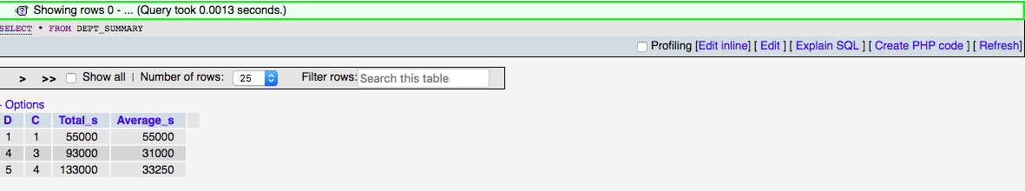

* 1. SELECT D, C  
     FROM DEPT\_SUMMARY  
     WHERE TOTAL\_S > 100000

The following query is allowed on the view. The result is given below:

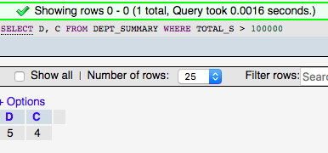

* 1. SELECT D, AVERAGE\_S   
     FROM DEPT\_SUMMARY  
     WHERE C > (SELECT C FROM DEPT\_SUMMARY WHERE D = 4);

The following query is allowed on the view. The result is given below:

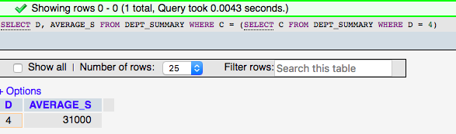

* 1. UPDATE DEPT\_SUMMARY  
     SET D = 3  
     WHERE D = 4;

The following UPDATE query is not allowed on the view.

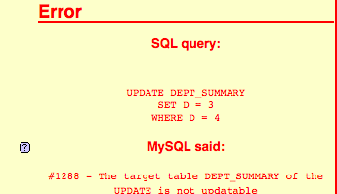

* 1. DELETE FROM DEPT\_SUMMARY  
     WHERE C > 4;

The following DELETE query is not allowed on the view.

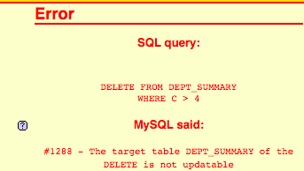

1. ***Specify the following queries in SQL on the (University) database schema in Figure below***

**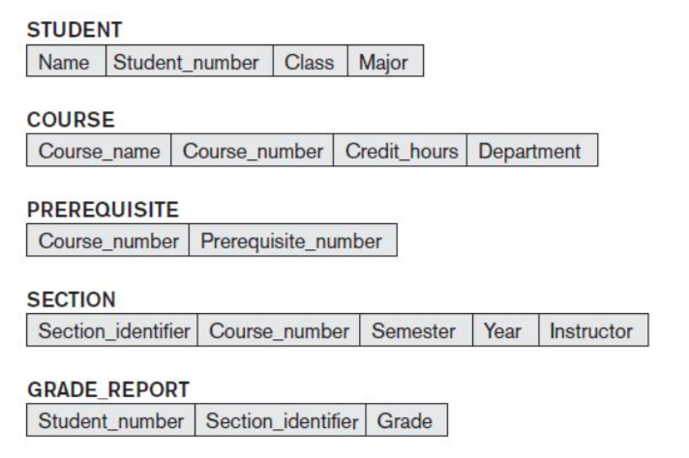**

* 1. ***Retrieve the names and major departments of all straight-A students. (students who have a grade of A in all their courses).***

[SELECT](http://localhost:8888/phpMyAdmin/url.php?url=https://dev.mysql.com/doc/refman/5.5/en/select.html) S.Name, S.Major

FROM STUDENT AS S, GRADE\_REPORT AS GR

WHERE S.Student\_number = GR.Student\_number

[AND](http://localhost:8888/phpMyAdmin/url.php?url=https://dev.mysql.com/doc/refman/5.5/en/logical-operators.html#operator_and) GR.Grade [LIKE](http://localhost:8888/phpMyAdmin/url.php?url=https://dev.mysql.com/doc/refman/5.5/en/string-comparison-functions.html#operator_like) 'A'

GROUP BY S.Student\_number

HAVING [COUNT](http://localhost:8888/phpMyAdmin/url.php?url=https://dev.mysql.com/doc/refman/5.5/en/group-by-functions.html#function_count)(\*) = (

[SELECT](http://localhost:8888/phpMyAdmin/url.php?url=https://dev.mysql.com/doc/refman/5.5/en/select.html) [COUNT](http://localhost:8888/phpMyAdmin/url.php?url=https://dev.mysql.com/doc/refman/5.5/en/group-by-functions.html#function_count)(\*)

FROM GRADE\_REPORT AS GR2

WHERE GR2.Student\_number = S.Student\_number

)

* 1. ***Retrieve the names and major departments of all students who do not have a grade of A in any of their courses.***

[SELECT](http://localhost:8888/phpMyAdmin/url.php?url=https://dev.mysql.com/doc/refman/5.5/en/select.html) S.Name, S.Major

FROM STUDENT AS S, GRADE\_REPORT AS GR

WHERE S.Student\_number = GR.Student\_number

[AND](http://localhost:8888/phpMyAdmin/url.php?url=https://dev.mysql.com/doc/refman/5.5/en/logical-operators.html#operator_and) GR.Grade [NOT](http://localhost:8888/phpMyAdmin/url.php?url=https://dev.mysql.com/doc/refman/5.5/en/logical-operators.html#operator_not) [LIKE](http://localhost:8888/phpMyAdmin/url.php?url=https://dev.mysql.com/doc/refman/5.5/en/string-comparison-functions.html#operator_like) 'A'

GROUP BY S.Student\_number

HAVING [COUNT](http://localhost:8888/phpMyAdmin/url.php?url=https://dev.mysql.com/doc/refman/5.5/en/group-by-functions.html#function_count)(\*) = (  
 [SELECT](http://localhost:8888/phpMyAdmin/url.php?url=https://dev.mysql.com/doc/refman/5.5/en/select.html) [COUNT](http://localhost:8888/phpMyAdmin/url.php?url=https://dev.mysql.com/doc/refman/5.5/en/group-by-functions.html#function_count)(\*)

FROM GRADE\_REPORT AS GR2

WHERE GR2.Student\_number = S.Student\_number

)

1. ***What are Triggers? Give an example of situation where triggers can be used?***

It can defined as rules set in the database which are activated based on an update to the database. They result in performing some defined operation on same or other tables or even performing of notifying by sending messages and so on. It can also be termed as a active listener which performs actions based on specific inputs given.

For example, if we use a server management database where real time server performance is being recorded for every interval of time. If the input entry reads that a specific server is running at a CPU Utilization of 80%, we could use TRIGGER to alert the owner based on the same. We could also push this data along with current applications running on the server to an ALERT table.